R-P-S Classification   
  
The RPS game in this project is used an used and exemplary image classification application, the instruction below will guide through the project’s code and involved datasets.

Dataset Creation

1. ***CreateDatasetMulti.py:*** 
   1. Run command : python script.py <path_to_dataset_directory>
   2. Used to convert raw images of dimension 400x400 to a matrix and save it as .pkl file, it also shuffles the points.
   3. Datasetpkl_sample consists of sample pkl files after running CreateDatasetMulit.py.
2. ***CombineDatasets.py:*** 
   1. Run command: python script.py <folder_path>
   2. Used to combine multiple .pkl dataset files to one large combined_dataset.pkl file which the models trains on.
3. ***gather_images.py:***
   1. Run command: python gather_images.py class_name no_of_images
   2. Used to collect automatically collect images of specified number, uses webcam to rapidly click pictures and saves the dataset images in folder of the given class_name.
   3. 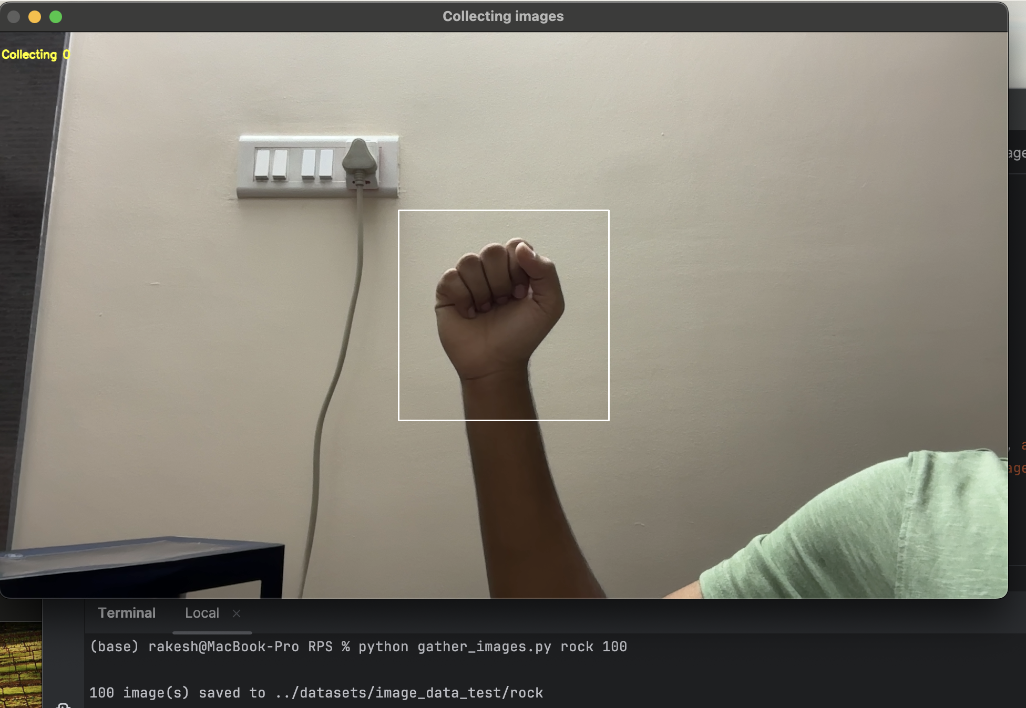
4. ***Training Dataset:*** combined_dataset_testing.py
5. ***Testing Dataset:*** combined_dataset_training.py

Models

1. **Trained_Models:** Directory consists of all the trained models as .pkl files, which can be loaded using python joblib and be used for analysis or live prediction.
2. **Model_Evaluation:** Directory consist .ipynb of all the model analysis, an ipynb folder for each. It also consist of Cross validation evaluation .ipynb file between all the models.

Please refer to the .ipynb files for the graphs and outputs for each model.

1. ***PresRecall4.py:*** 
   1. Run command: python PresRecall4.py dataset_path.pkl model_path.pkl
   2. Used to calculate the precision-recall for given model and given dataset, its used only for testing.
   3. Sample Output:
      1. Given a dataset .pkl file and a trained model, the code iterates through the dataset and calculates precision and recall

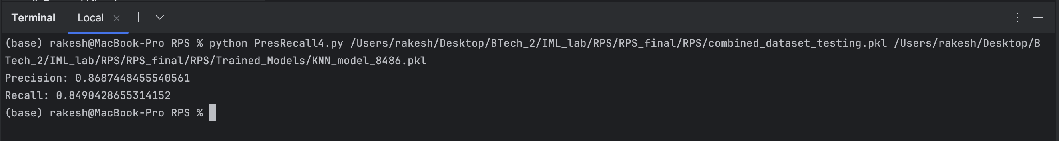

Live Prediction:

1. ***LivePred.py:***
   1. Run command: python LivePred3.py <model_path.pkl>
   2. Used to perform predictions on live data, the webcam is used to get a stream of images and the predictions are sequentially printed in terminal.
   3. Sample Outputs:
      1. 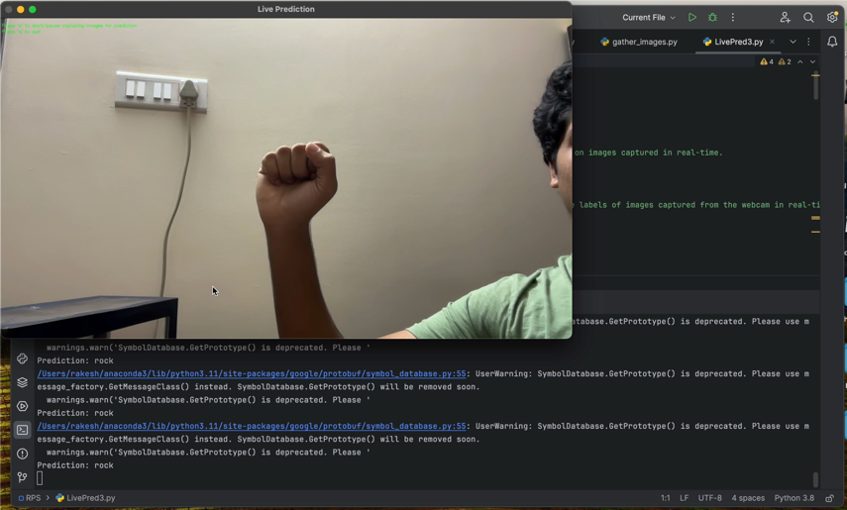
      2. 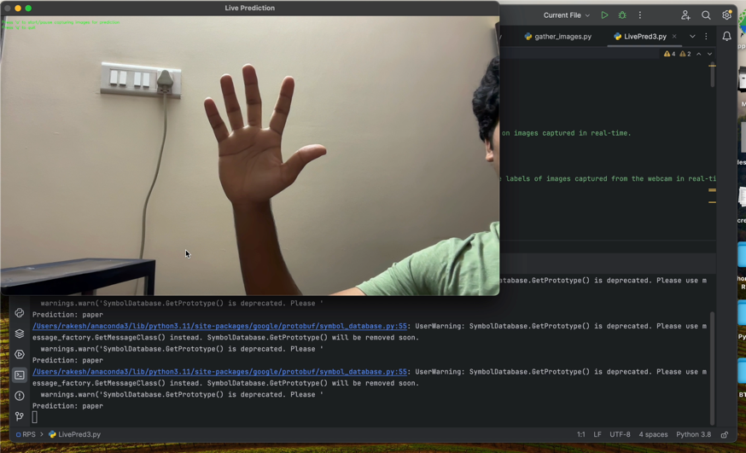
      3. 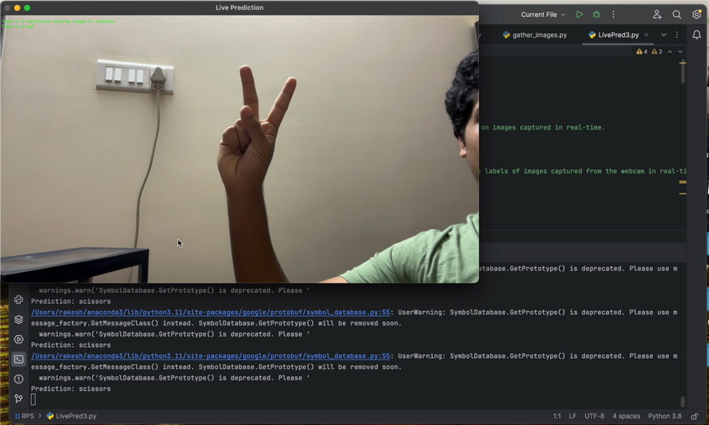
2. ***live_feed_lndmrk.py***
   1. Run command: python live_feed_lndmrk.py
   2. Used to for representation of Mediapipe’s hand landmarking feature.
   3. Sample Outputs:
      1. 